

**NOMBRE:** BYRON CONDOR

**MATERIA**: PROGRAMACION ORIENTADA A OBJETOS

**NRC:** 3638

**TALLER #1**

Realizar capturas de pantalla del procedimiento para realizar un repositorio local en nuestro computador.

**Take screenshots of the procedure to make a local repository in our computer.**

**1.- Download and install the git program, which will help us to configure our repository**.

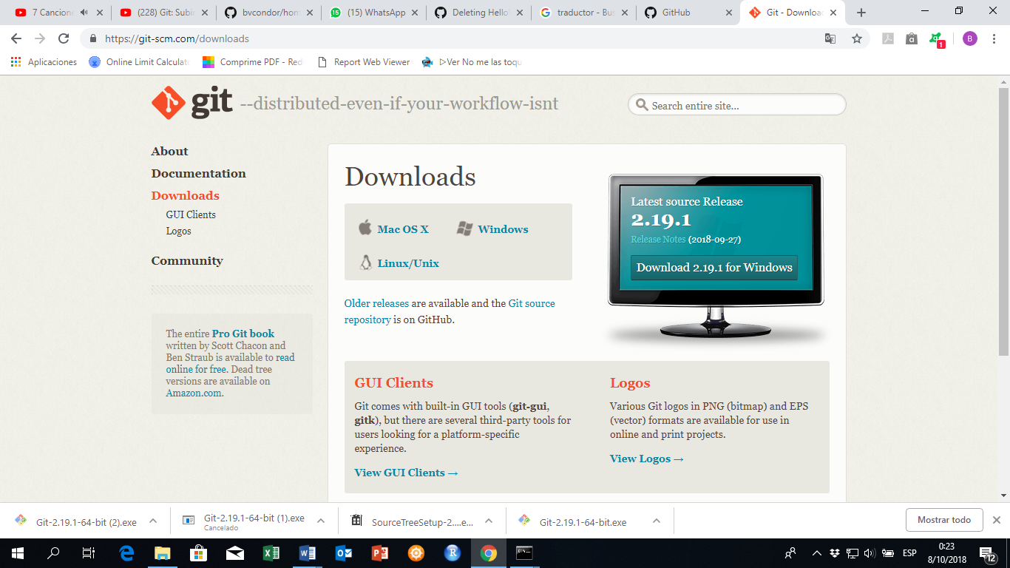

2. open our github

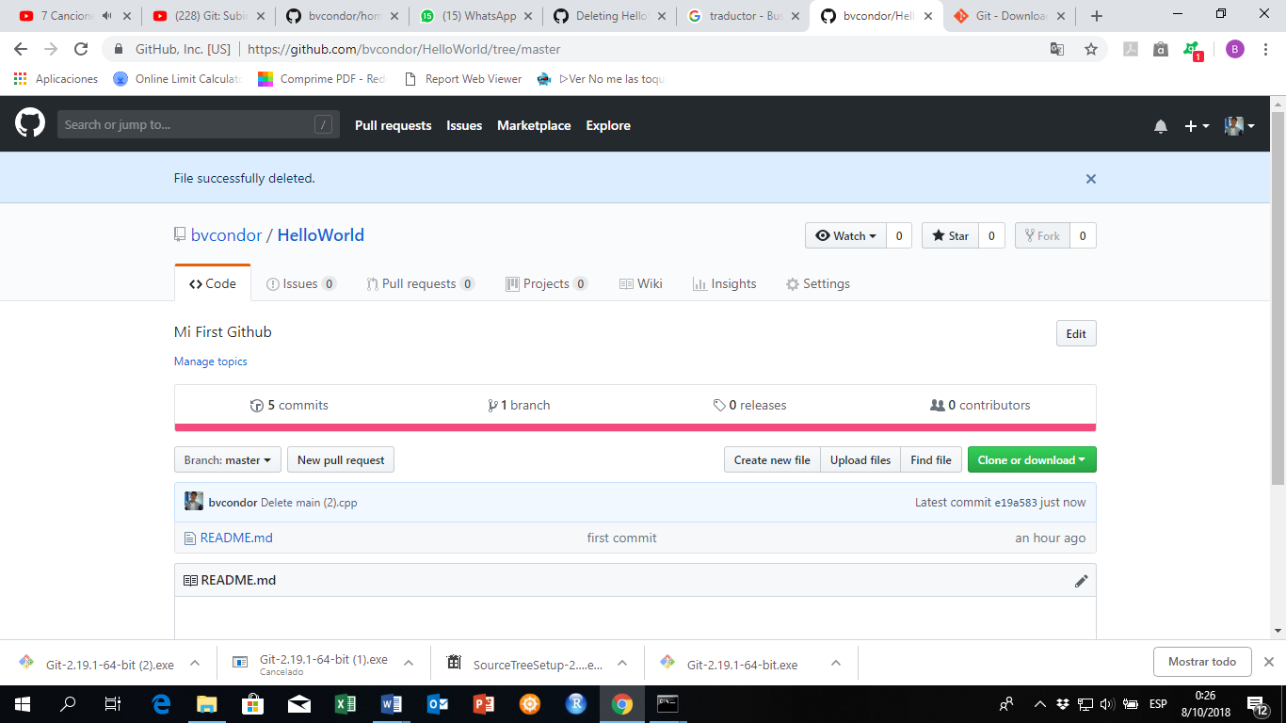

**3.. open the command prompt screen in Windows**

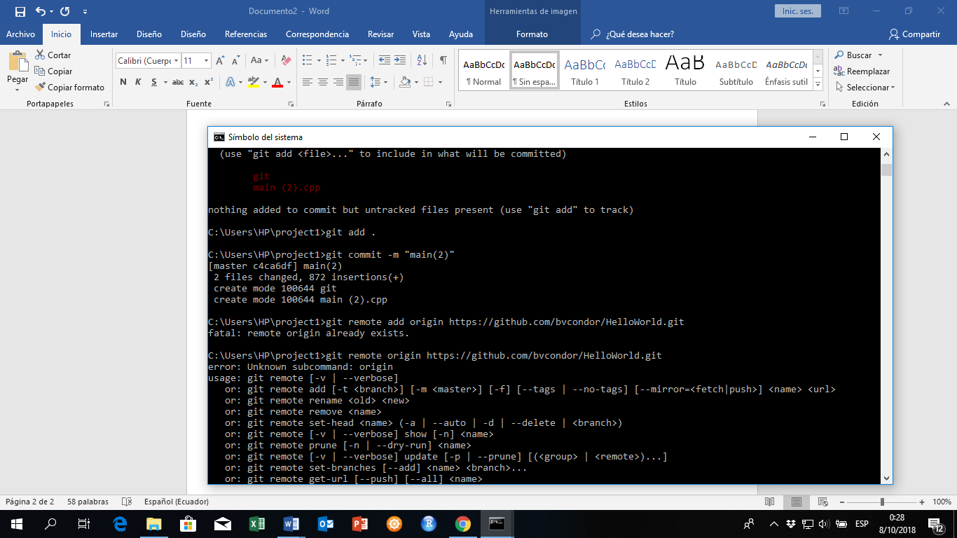

4. **execute the steps that are specified in github**

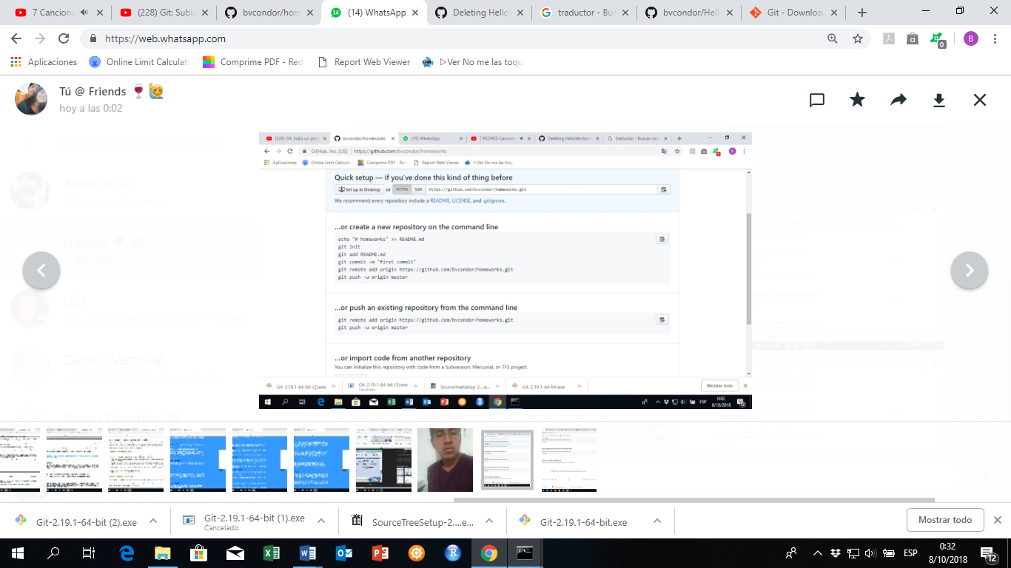

**5. Execute them in the order indicated:**

**5.1**

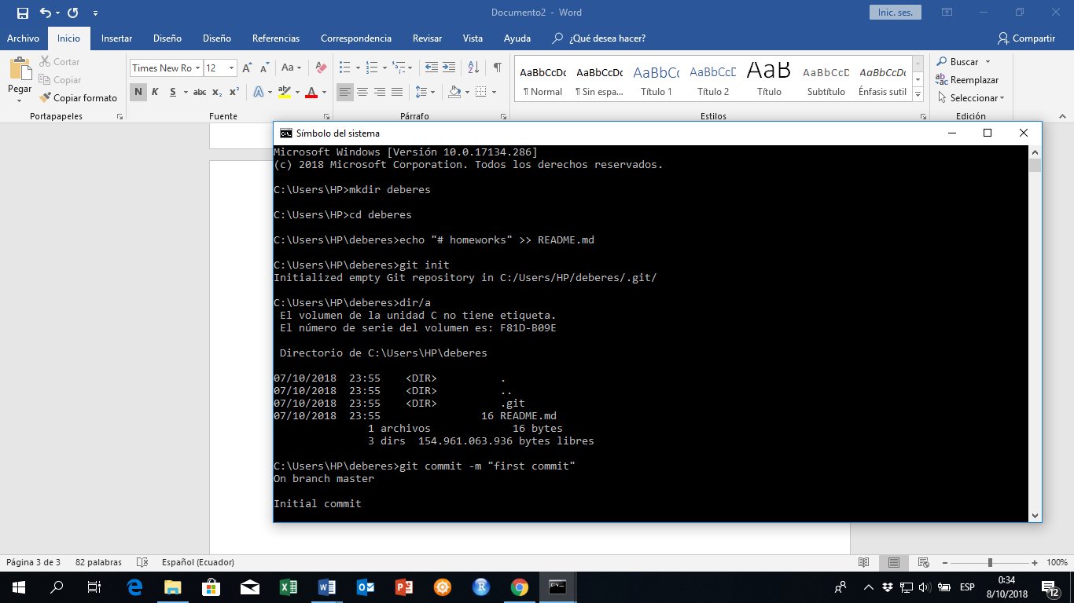

**5.2**

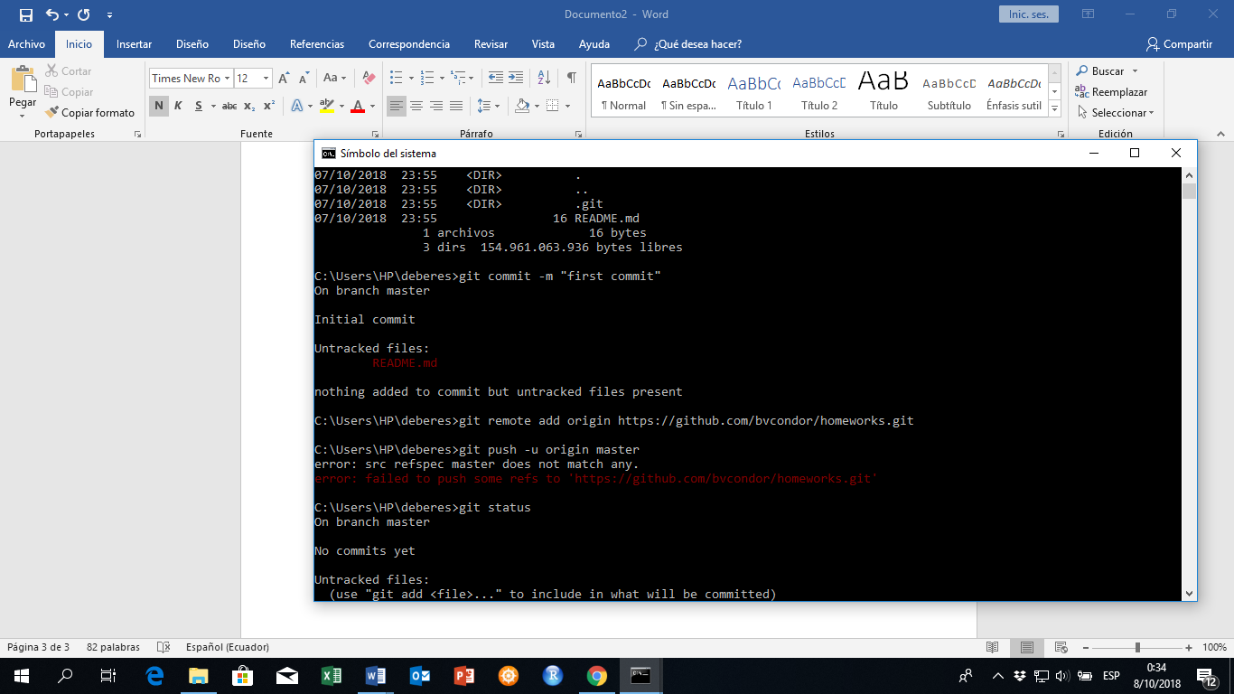

**5.3**

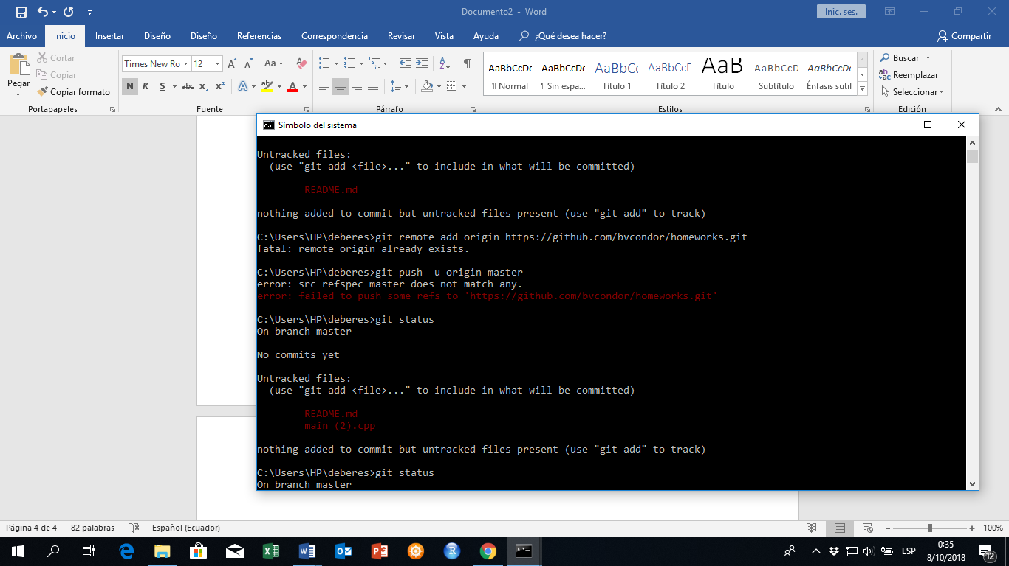

**5.4**

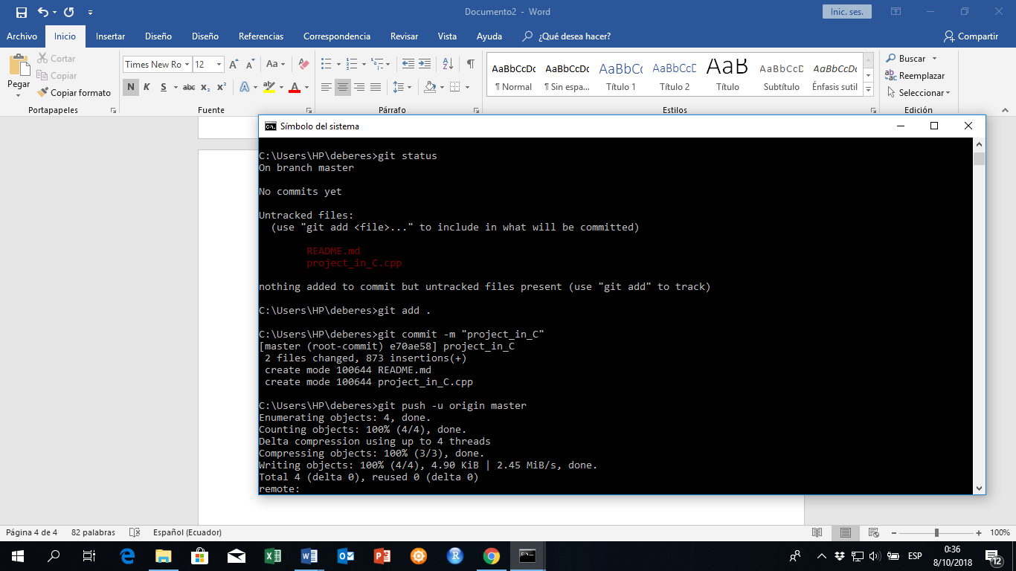

**5.5**

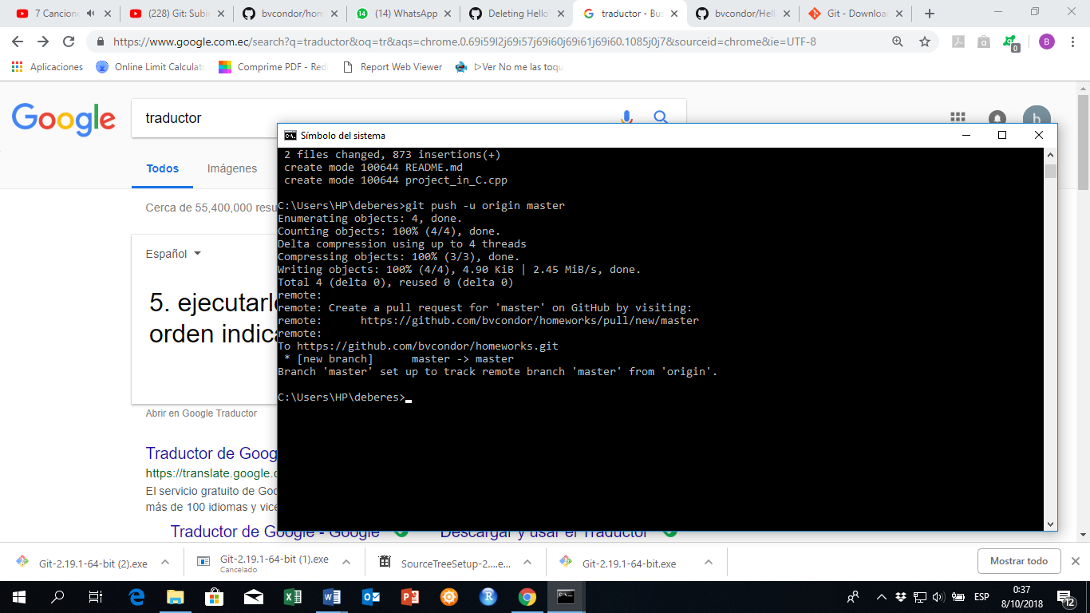

**At the end of executing the commands a local repository will be created and we will be able to share files between git hub and our personal computer.**

